EXPERIMENT 9 – FIR FILTER DESIGN:

CODE:

# -*- coding: utf-8 -*-

"""

Created on Tue Apr 23 11:19:04 2024

@author: sanja

"""

import matplotlib.pyplot as plt

import numpy as np

from scipy.signal import freqz

wc=(np.pi/3)

M=11

a=(M-1)/2

b=(wc/np.pi)

hd_n=[]

n = np.arange(M)

hd_n = np.sin(wc * (n - a)) / (np.pi * (n - a))

hd_n[M // 2] = b

def rectangular_window(M):

n = np.arange(M)

n[0]=1

return n/n

def hamming_window(M):

n = np.arange(M)

return 0.54 - 0.46 * np.cos(2 * np.pi * n / (M - 1))

def hanning_window(M):

n = np.arange(M)

return 0.5 - 0.5 * np.cos(2 * np.pi * n / (M - 1))

hn_r= hd_n * rectangular_window(M)

print("Rectangular window coefficients:",hn_r)

plt.figure(2)

plt.subplot(3,1,1)

wr,Hr=freqz(hn_r)

plt.plot(wr*57.29, 20*np.log10(abs(Hr)))

plt.grid(True)

plt.title('Frequency Response of Linear Phase Low-pass FIR Filter - Rectangular window')

plt.xlabel('Frequency (degrees)')

plt.ylabel('Magnitude (dB)')

hn_m = hd_n * hamming_window(M)

print("\n Hamming window coefficients:",hn_m)

wm,Hm=freqz(hn_m)

plt.subplot(3,1,2)

plt.grid(True)

plt.plot(wm*57.29,20 * np.log10(abs(Hm)))

plt.title('Frequency Response of Linear Phase Low-pass FIR Filter - Hamming window')

plt.xlabel('Frequency (degrees)')

plt.ylabel('Magnitude (dB)')

hn_n = hd_n * hanning_window(M)

print("\n Hanning window coefficients:",hn_n)

wn,Hn=freqz(hn_n)

plt.subplot(3,1,3)

plt.grid(True)

plt.plot(wn*57.29,20 * np.log10(abs(Hn)))

plt.title('Frequency Response of Linear Phase Low-pass FIR Filter - Hanning window')

plt.xlabel('Frequency (degrees)')

plt.ylabel('Magnitude (dB)')

plt.figure(1)

plt.subplot(311)

plt.stem(hn_r)

plt.title('window Coefficients - Rectangular window')

plt.xlabel('n')

plt.ylabel('Amplitude')

plt.subplot(312)

plt.stem(hn_m)

plt.title('window Coefficients - Hamming window')

plt.xlabel('n')

plt.ylabel('Amplitude')

plt.subplot(313)

plt.stem(hn_n)

plt.title('window Coefficients - Hanning window')

plt.xlabel('n')

plt.ylabel('Amplitude')

plt.figure(3)

plt.subplot(3,1,1)

plt.grid(True)

plt.plot(wr*57.29,np.angle(Hr))

plt.title('Phase Response of Low-pass FIR Filter - Rectangular window')

plt.xlabel('Frequency (degrees)')

plt.ylabel('Phase')

plt.subplot(3,1,2)

plt.grid(True)

plt.plot(wm*57.29,np.angle(Hm))

plt.title('Phase Response of Low-pass FIR Filter - Hamming window')

plt.xlabel('Frequency (degrees)')

plt.ylabel('Phase')

plt.subplot(3,1,3)

plt.grid(True)

plt.plot(wn*57.29,np.angle(Hn))

plt.title('Phase Response of Low-pass FIR Filter - Hanning window')

plt.xlabel('Frequency (degrees)')

plt.ylabel('Phase')

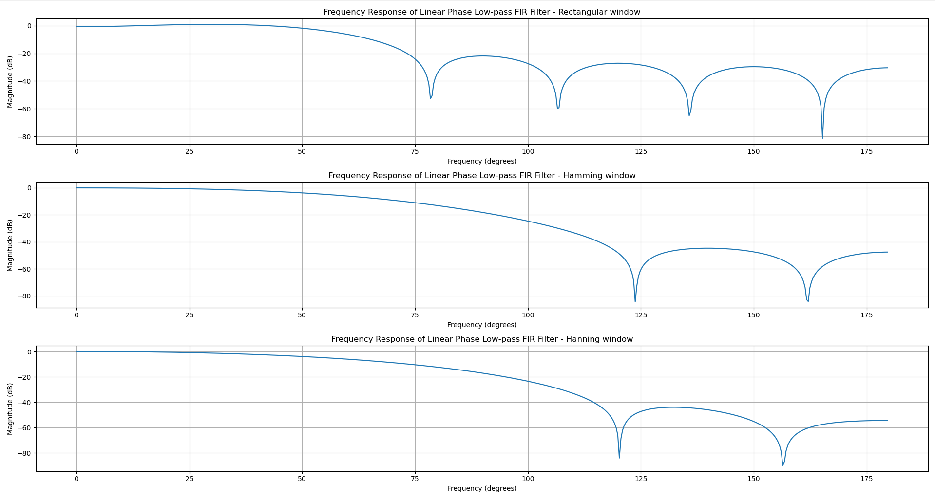OUTPUT:

